 | ASIAN PARLIAMENTARY ASSEMBLY  Standing Committee on Economic  and Sustainable Development  (Virtual Meeting) | 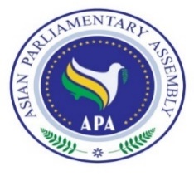
Manama, Kingdom of Bahrain
20 May 2021
Delegation of: ………………………………
Name of Parliament

No. | First Name | Last Name | Position | Photo
Host Secretariat:  Email: ipbahrain@nuwab.bh and  m.bindaina@nuwab.bh  Tel : (+973) 37330003  (+973) 33447790 | CC to APA Secretariat:  Email :secretariat@asianparliament.org  Fax : (+98-21) 33517408  Phone : (+98-21) 33517406-7

